Python.org installation and Use

The following results:

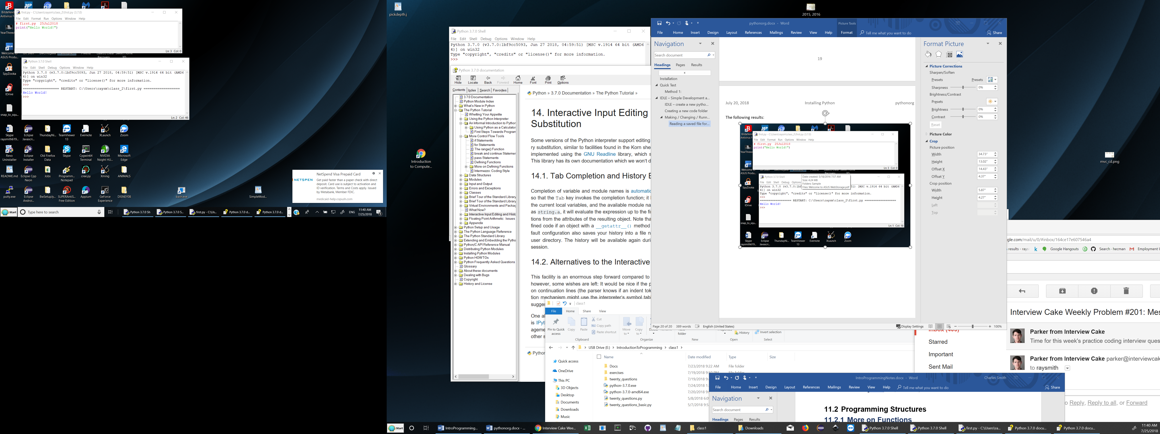

After a change, Save (or Ctrl-S), and Run (or F5):

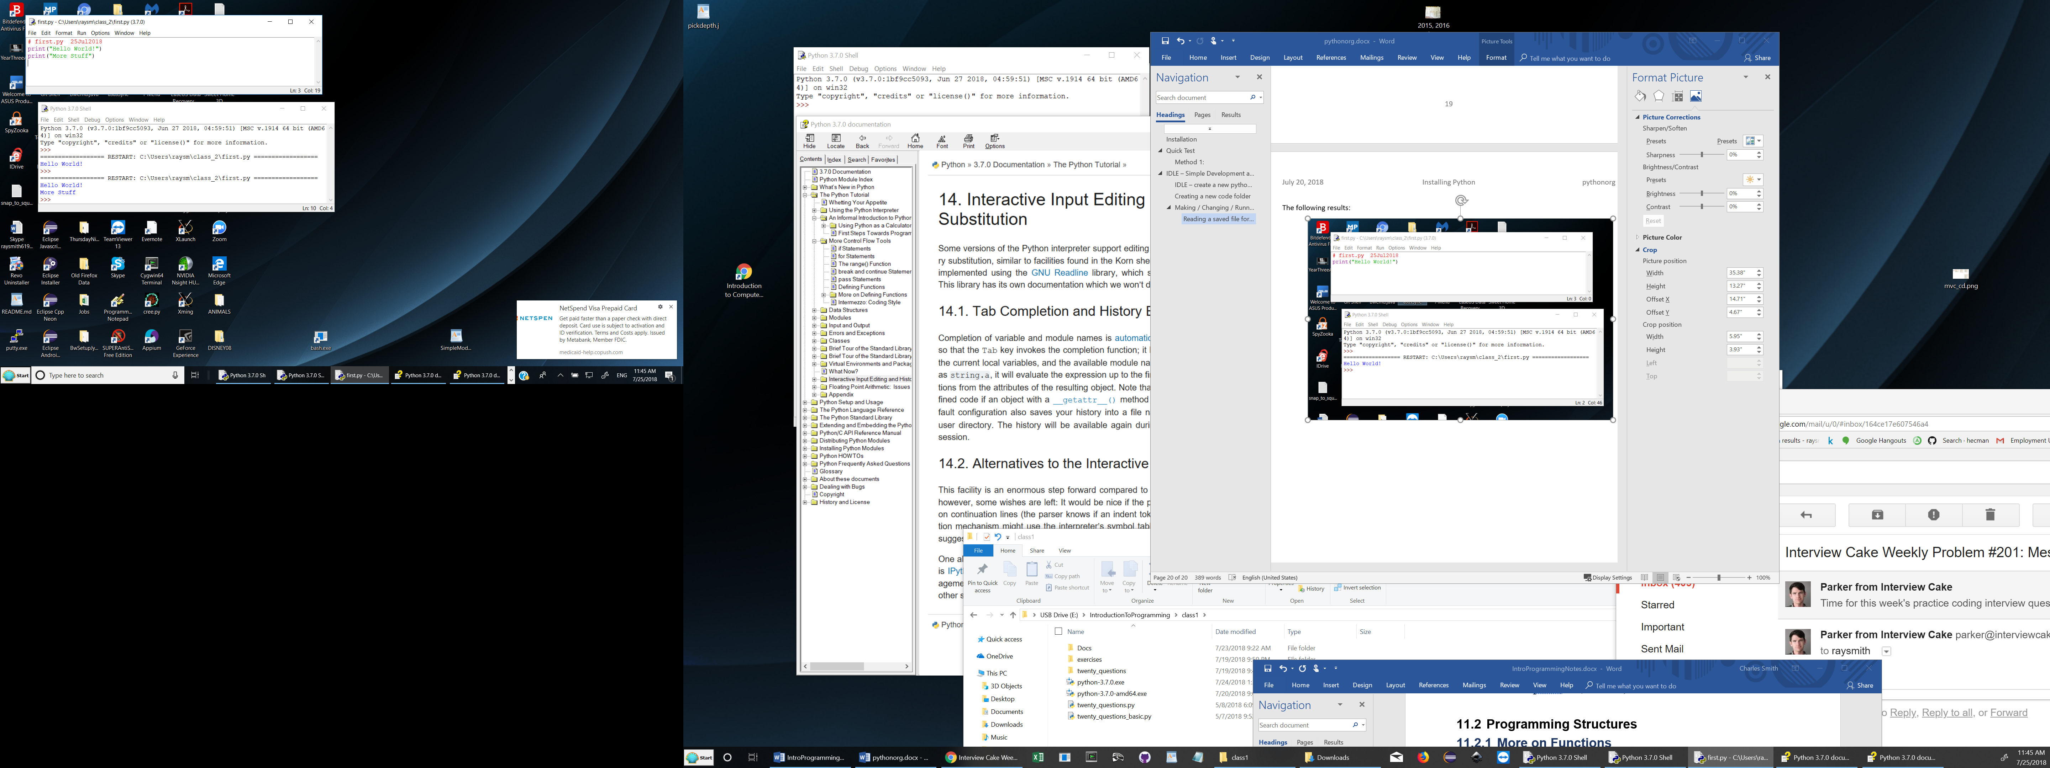

## Idle Help

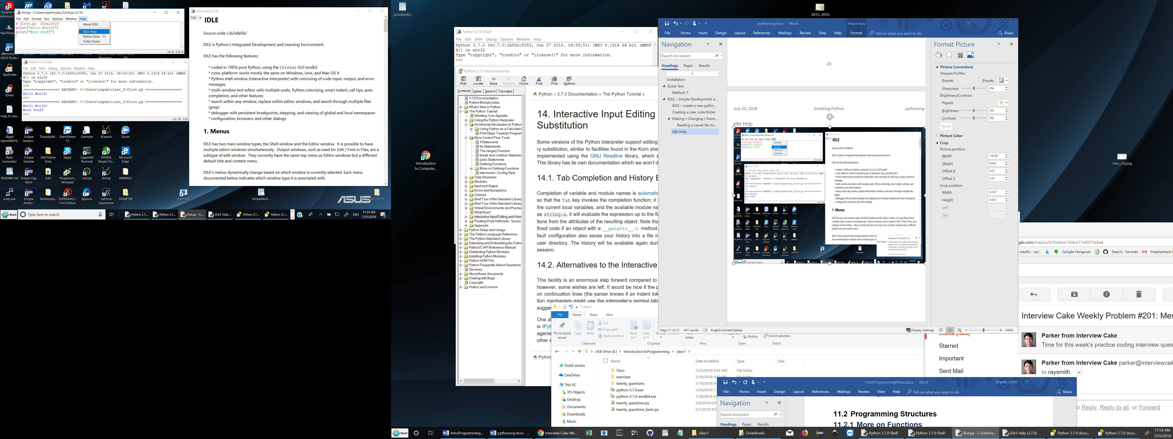

## IDLE Python Docs

Including a great Python Tutorial

